Nabila Alia Zahra | Rangkuman Minggu 10 Pengaplikasian Arduino menggunakan Tinkercad | Senin, 07 November 2022
Nabila Alia Zahra |  | 16TNK5043 ( Aplikasi Mikrokontroler)
3NK |  | Ferry Satria, BSEE.,M.T.  Rahmawati Hasanah,S.ST.,M.T.

Arduino :
Void Setup → untuk inisialisasi dan deklarasi Void Loop → untuk memasukan main program

Program untuk mengaktifkan LED, logic 1 menyala, logic 0 mati
// C++ code
//
void setup()
{
pinMode(2, OUTPUT);
}

void loop()
{
digitalWrite(2, HIGH);
}

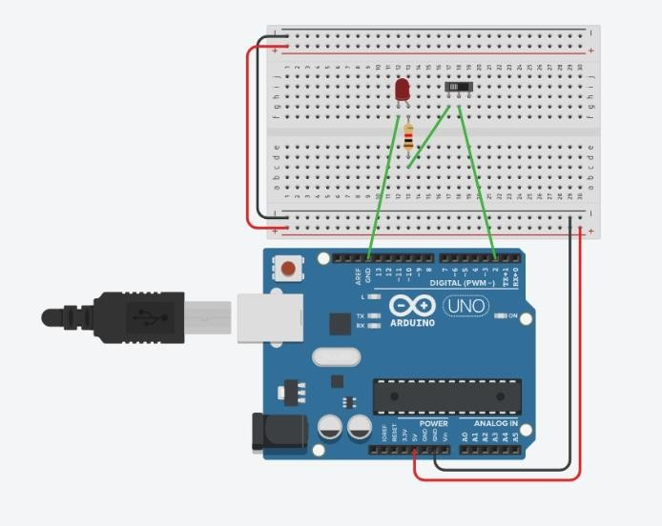

Program untuk mengaktifkan LED, logic 1 flip flop, logic 0 mati

// C++ code
//
void setup()// inisialisasi dan deklarasi
{
pinMode(2, OUTPUT);//Supaya jadi output
}

void loop()//Main program
{
digitalWrite(2, HIGH);// biar berlogic 1 delay(1000); // Wait for 1000 millisecond(s) digitalWrite(2, LOW);
delay(1000); // Wait for 1000 millisecond(s)
}

Program untuk menampilkan angka 2 pada seven segmen common cathode
int a = 6; //Segment A int b = 7; //Segment B int c = 8; //Segment C int d = 9; //Segment D int e = 10; //Segment E int f = 11; //Segment F int g = 12; //Segment G int k,n;
int pin[] = {0,0,1,0,0,1,0};
void setup()
{
for (k=6 ; k<13 ; k++) pinMode (k,OUTPUT);
}

void loop() {
for (n=0 ; n<7 ; n++) { digitalWrite(n+6 , pin[n]);
}
}

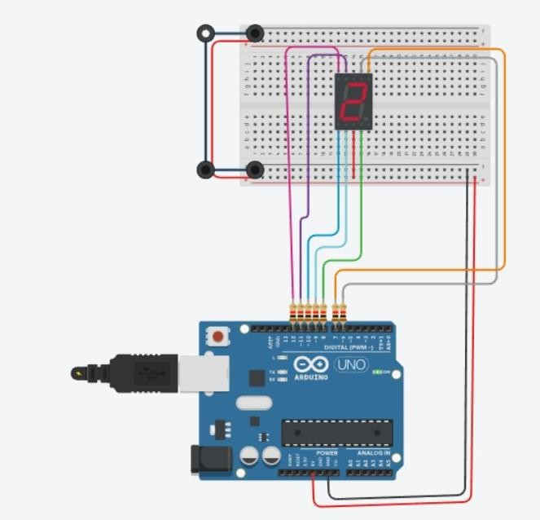
Program menampilkan huruf 2 dan 3 secara bergantian
int a = 6; //Segment A int b = 7; //Segment B int c = 8; //Segment C int d = 9; //Segment D int e = 10; //Segment E int f = 11; //Segment F int g = 12; //Segment G int k,n;
int pin1[] = {0,0,1,0,0,1,0};
int pin2[] = {0,0,0,0,1,1,0};
void setup()
{
for (k=6 ; k<13 ; k++) pinMode (k,OUTPUT);
}
void loop() {
for (n=0 ; n<7 ; n++) { digitalWrite(n+6 , pin1[n]);
}
delay(1000);
for (n=0 ; n<7 ; n++) { digitalWrite(n+6 , pin2[n]);
}
delay(1000);
}

int a = 6; //Segment A int b = 7; //Segment B int c = 8; //Segment C int d = 9; //Segment D int e = 10; //Segment E int f = 11; //Segment F int g = 12; //Segment G int k,n;
int pin1[] = {0,0,0,0,0,0,1};
int pin2[] = {1,0,0,1,1,1,1};
int pin3[] = {0,0,1,0,0,1,0};
int pin4[] = {0,0,0,0,1,1,0};
int pin5[] = {1,0,0,1,1,0,0};
int pin6[] = {0,1,0,0,1,0,0};
int pin7[] = {0,1,0,0,0,0,0};
int pin8[] = {0,0,0,1,1,1,1};
int pin9[] = {0,0,0,0,0,0,0};
int pin10[] = {0,0,0,0,1,0,0};
void setup()
{
for (k=6 ; k<13 ; k++) pinMode (k,OUTPUT);
}
void loop() {
for (n=0 ; n<9 ; n++) { digitalWrite(n+6 , pin1[n]);
}
delay(1000);
for (n=0 ; n<9 ; n++) { digitalWrite(n+6 , pin2[n]);
}
delay(1000);
for (n=0 ; n<9 ; n++) { digitalWrite(n+6 , pin3[n]);
}
delay(1000);
for (n=0 ; n<9 ; n++) { digitalWrite(n+6 , pin4[n]);
}
delay(1000);
for (n=0 ; n<9 ; n++) { digitalWrite(n+6 , pin5[n]);
}
delay(1000);
for (n=0 ; n<9 ; n++) { digitalWrite(n+6 , pin6[n]);
}
delay(1000);
for (n=0 ; n<9 ; n++) { digitalWrite(n+6 , pin7[n]);

}
delay(1000);
for (n=0 ; n<9 ; n++) { digitalWrite(n+6 , pin8[n]);
}
delay(1000);
for (n=0 ; n<9 ; n++) { digitalWrite(n+6 , pin9[n]);
}
delay(1000);
for (n=0 ; n<9 ; n++) { digitalWrite(n+6 , pin10[n]);
}
delay(1000);
}

